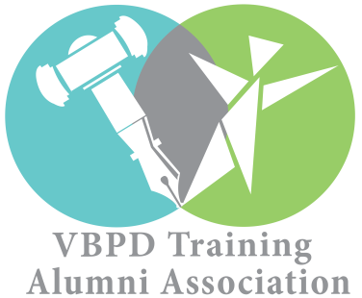***NoVA Regional Alumni Chapter is sponsoring a*  
Trip to the State Capitol  
Tuesday, January 31, 2017**

**To support The Arc of Virginia’s DD Advocacy Day**

YLF and PIP Alumni are invited to participate and transportation cost will be covered and or reimbursed by the VBPD Alumni Development Program.

Buses will depart from: (info needed based on Region)

Buses will return by: (info need from Regions)

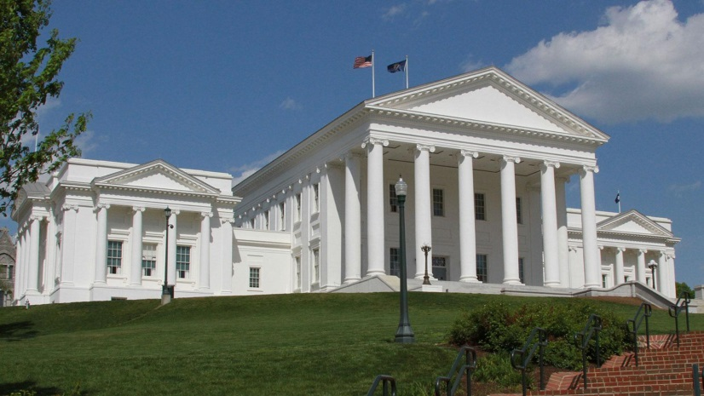

**DD ADVOCACY DAY AGENDA**

**General Assembly Building**

**201 N 9th St, Richmond, VA 23219**

8:00 am -10:30 am – Schedule Appointments prior to January 20th with your Legislatures to meet them on January 31, 2017 during this timeframe at the General Assembly Building to share your concerns on policy issues effecting persons with Disabilities.

**Bell Tower located in front of the State Capitol**

10:45 am – 11:30 am DD ADVOCACY DAY RALLY: Meet at the BELLS Tower which is located in front of the State Capitol to stand in unity and solidarity with other agencies, coalitions, organizations and advocates, to demonstrate by your presence the importance of prioritizing DD policy issues effecting persons with disabilities in the Commonwealth.

**St. Paul’s Episcopal Church**

11:35am – 12:30am: Lunch at no cost to the ALUMNI will be held at the St. Paul’s Episcopal Church located at 815 E Grace St, Richmond, VA 23219 (church located across from the General Assembly Building).Buses will depart from State Capitol (Bank Street) back to your home at 1:30pm.

***RSVP’s are REQUIRED*** *and should be sent to (insert name and email of Chapter Representative) and to ronita.wilson@vbpd.virginia.gov by Tuesday, January 17, 2017 by 5:00 pm.*

